CS 255 System Design Document Template

This template lays out all the different sections that you need to complete for Project Two. Each section has guidance to prompt your thinking. You will need to continually reference the interview transcript as you work to make sure that you are addressing your client’s needs. There is no required length for the final document. Instead the goal is to complete each section based on what your client’s needs are. Remove this note when you are finished, and replace all bracketed text with the relevant information.

UML Diagrams

UML Use Case Diagram
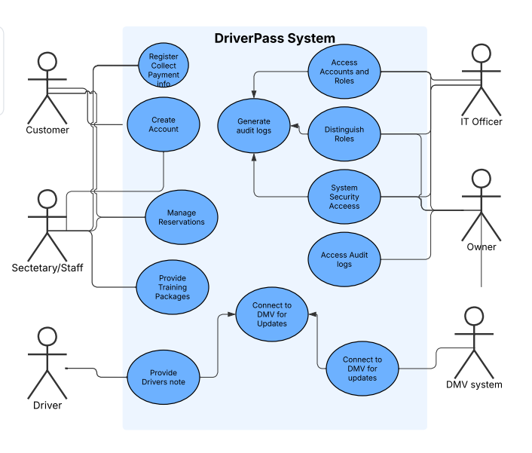

UML Activity Diagrams
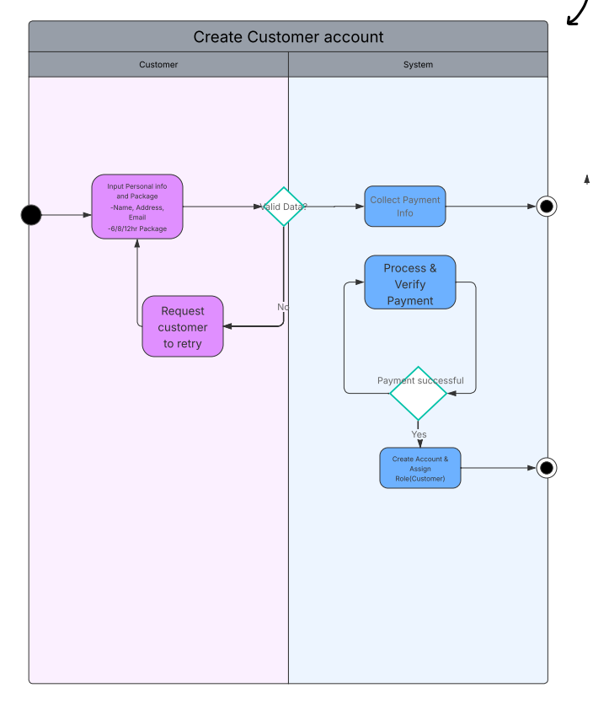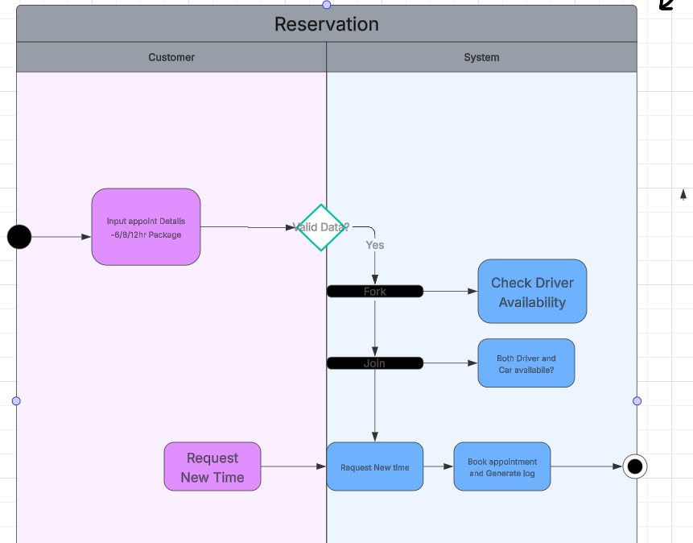

UML Sequence Diagram
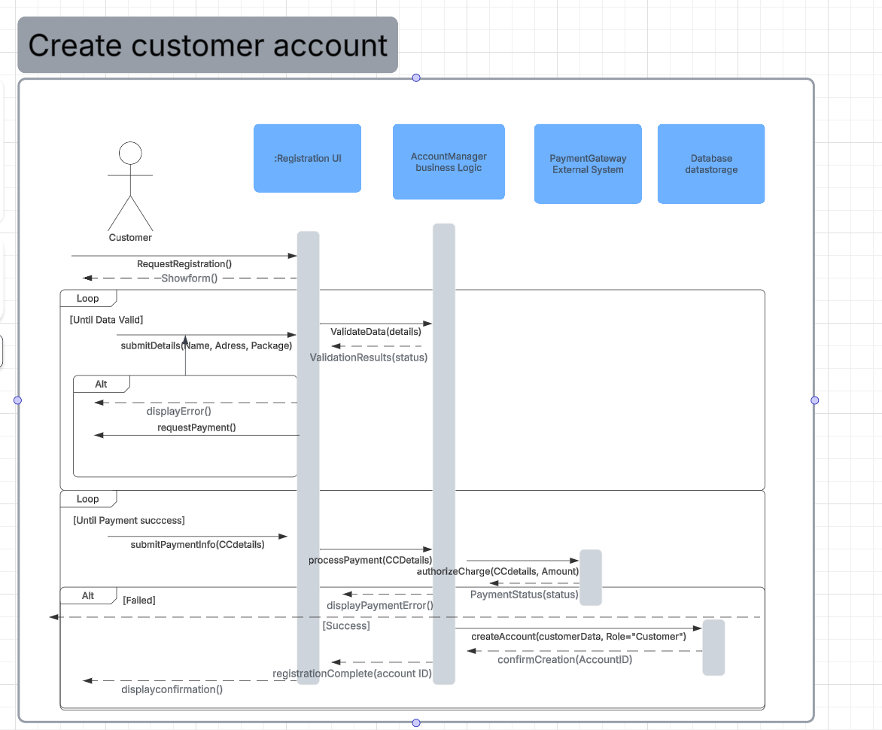

UML Class Diagram
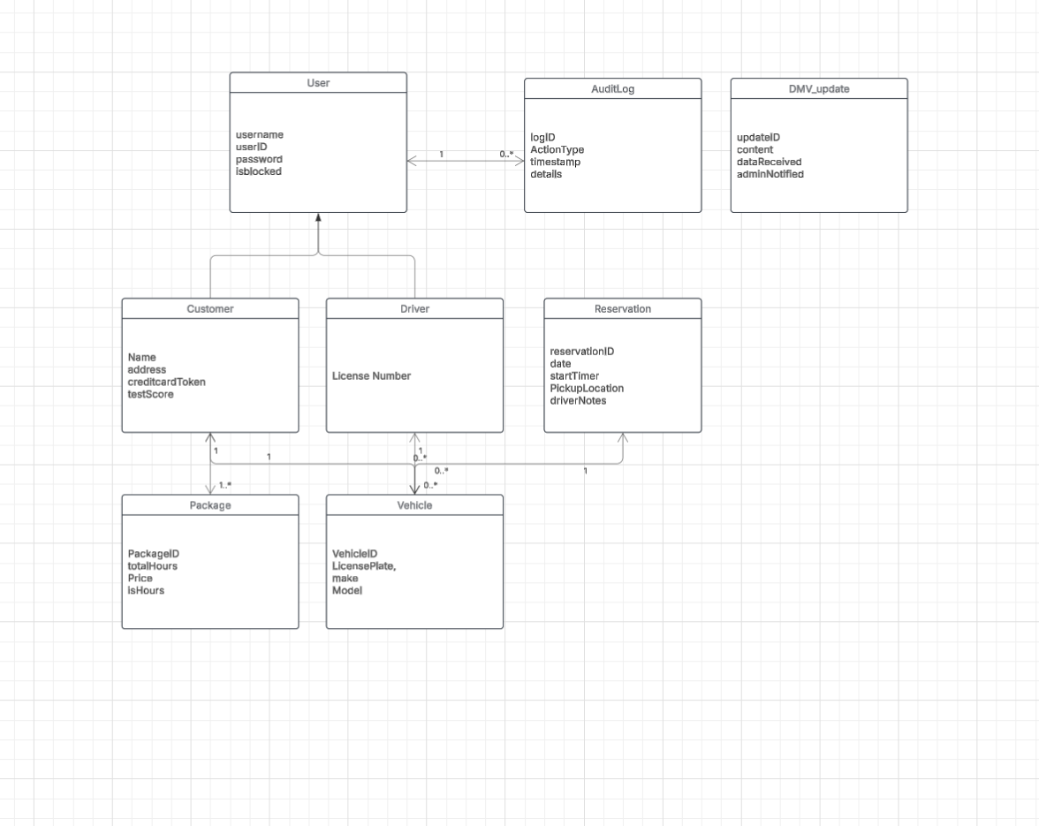

Technical Requirements
- Hardware and Infrastructure
The system will require a modern, cloud-based infrastructure to handle user traffic, data and storage. The focus will need to be on Deployment Environment, the hosting platform. Database server, likely mySQL to store complex relationships. Application server, this will be the cpu or ram needed to run the reservation manager and fork/join resources part of it and finally the network and security which will be the encryption across all forms of communications specifically and most importantly during payment processing.
- Software and Development tools.
The software must support web application develop and secure third-party integration, the best languages for this will be python, java, possibly C# for a secure scalable webservice. The front end framework will need a responsive registration UI and reservation management for staff. The API will be required to handle resourceAvability as well as manager logic and we will need some sort of version control for constant development.
- Third-Party Integrations and their Security
We will need multiple external systems that fall outside our system boundaries. This includes DMV compliance, authentication services and payment gateway integration. We must have some sort of security and avoid storing raw card numbers and we must be certain these accesses to our system cant be used to later be used for malicious means against the system.
4 . System Operation and Compliance
The system must be capable of creating audit logs that are non deleteable as supported by the AuditLog class. We will also want data backup and recovery for any missing and possible loss from Customer reservation and package. The last concern how resources manage to assure that certain things such as vehicles and their drivers are both available before ever confirming a reservation and wasting our resources.

